CEY ADAMS, DEPARTURE: 40 Years of Art and Design

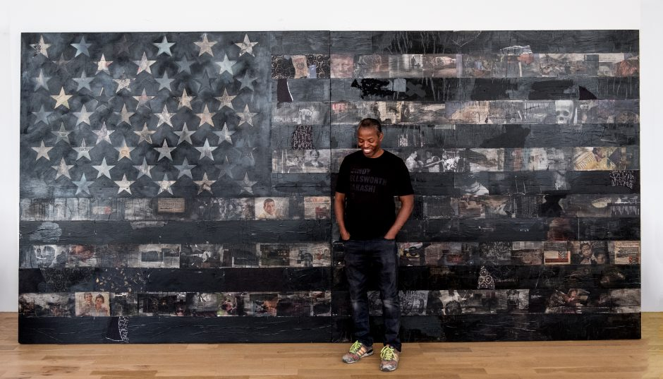

As a visionary artist, cultural pioneer, and innovative designer, Cey Adams (b. 1962) personifies the New York City hustle. A graffiti and design legend, Adams honed his art skills in the late 1970s, painting the streets and trains of NYC before moving downtown where street art was leaking into the city's high-end galleries. Like his pop art contemporaries of the time, Adams understood the power of images, media, and advertising, a position that left him uniquely suited to give visual life to a new movement called hip hop.

CEY ADAMS, DEPARTURE: 40 Years of Art and Design examines Adams' more than four decades of work, spanning from graffiti to designing album covers, t-shirts, and posters for some of hip hop's foundational acts, as well as his expanding commercial collaborations with global brands. With a return to his roots more than a decade ago, Adams has explored his evolving art through fine art and mixed media collages that evoke nostalgia while looking deeper into an Americana that is effortlessly authentic.

This exhibition is arranged chronologically and broken into six categories:

1. Early career - ‘70s & ‘80s, graffiti, photography, lifestyle, history
- This section includes early photography of Martha Cooper, Ricky Powell, Keith Haring, the Beastie Boys, along with flyers, drawings, and posters.

2. Def Jam + Design
- The section highlights Adams work at Def Jam. It includes reproductions of album covers, album photography, logo development sketches, and 3D artist logos.

3. Products + Commercial collaborations/ installations
- This section contains original works from Adams while working with major commercial brands like Levi’s and Coca-Cola. This includes custom Levi’s jackets, books, product displays, apparel, and logo design (i.e. Chappelle Show and Black Flag headphones).

4. Studio practice - Trusted Brands, Flags
- Adams has maintained a studio practice throughout his career. This section highlights that work. See next page for sample checklist.

5. TV/ Multimedia (interview on mural practice)

6. Art and Activism Present Day
- This section is dedicated to Adams’ current work with Black Lives Matter, Murals for the Movement, photography with Public Enemy & Chappelle Show protest photo, Billy Holiday (work on paper, framed), Levi’s exhibition tees, trucker jackets, and Levi’s sign from Art Basel.

This exhibition is organized by the Boston University Art Galleries and curated by Liza Quinonez in collaboration with Cey Adams.

Sample Checklist:

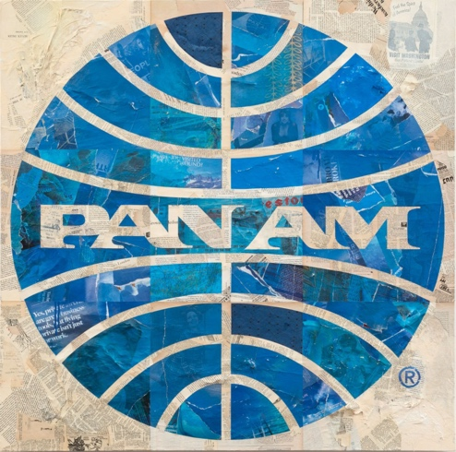

Pan Am
handmade fiber paper, magazines, spray paint and acrylic ink on canvas
48 X 48 X 2 inches
2015

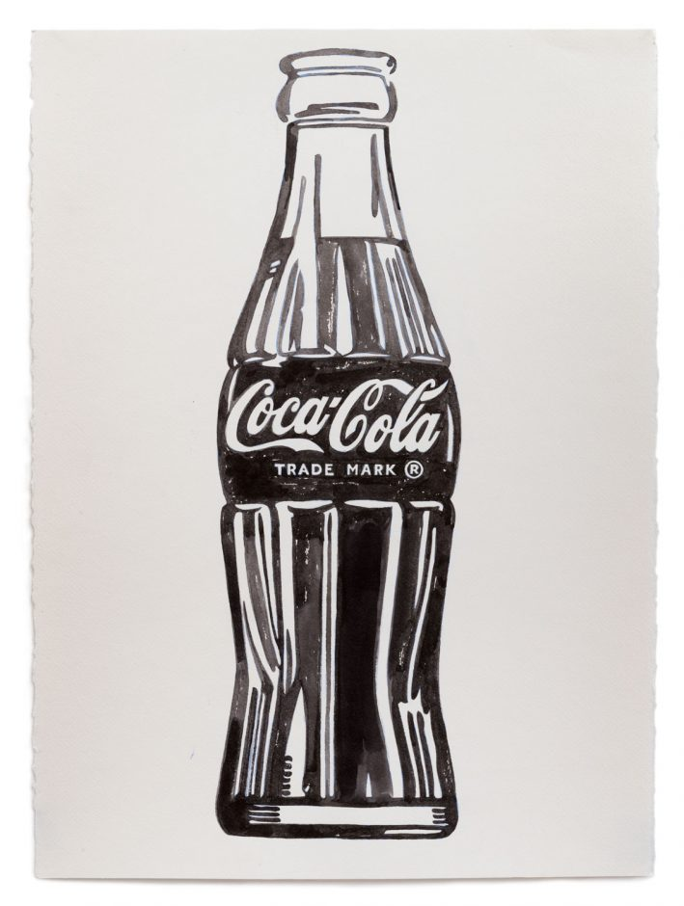
Coca-Cola Bottle
india ink on paper
30 X 22 inches
2015

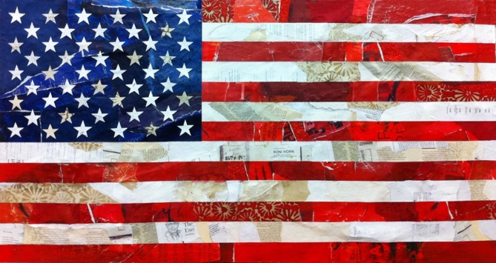
American Flag
handmade fiber paper, magazines and acrylic on wood panel
46 X 24 X 5 inches
2014

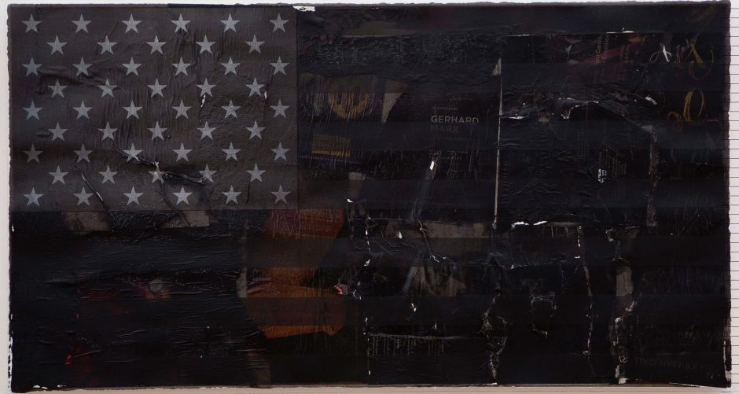

No Time
Mixed media on paper mounted on canvas
18 x 34 inches
2016

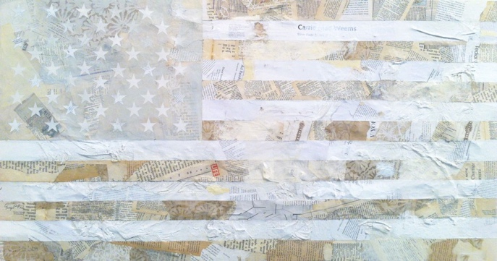

American Flag (White)
handmade fiber paper, magazines and acrylic on wood panel
46 X 24 X 5 inches
2014

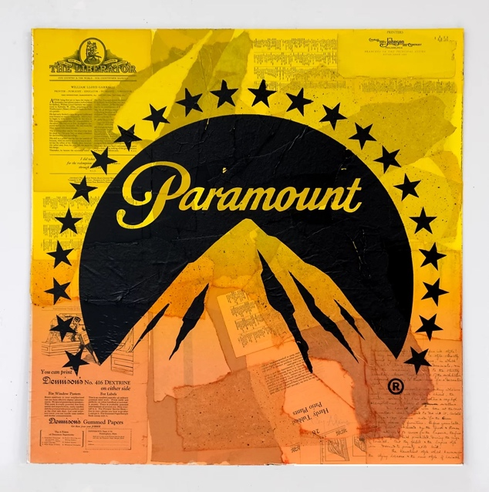

Paramount (Yellow Mountain)
silkscreen and mixed media on panel board
32 X 32 inches
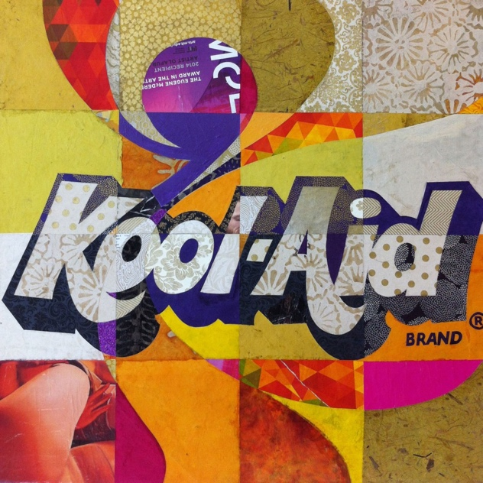

Kool-Aid
handmade fiber paper, magazines and acrylic on canvas
24 X 24 x 2 inches
2014

